4CS015 – Workshop #5 TO BE SUBMITTED
Name:
Student ID:
This is a marked workshop. It forms the second part of your portfolio. You will need to complete the workshop and then submit a copy of this document with a title that follows the following format (“DENNETT 1234567 wsp5.docx”), via CANVAS, by the deadline.
Workshop tasks:
Arithmetic Logic Unit:
Load the LogSim Arithmetic Logic Unit Circuit alu.cct from inside the logsim application (You'll find it in the logsim folder) (You may need to right-click on the link to download the file instead of opening it in the browser). It should look like this:
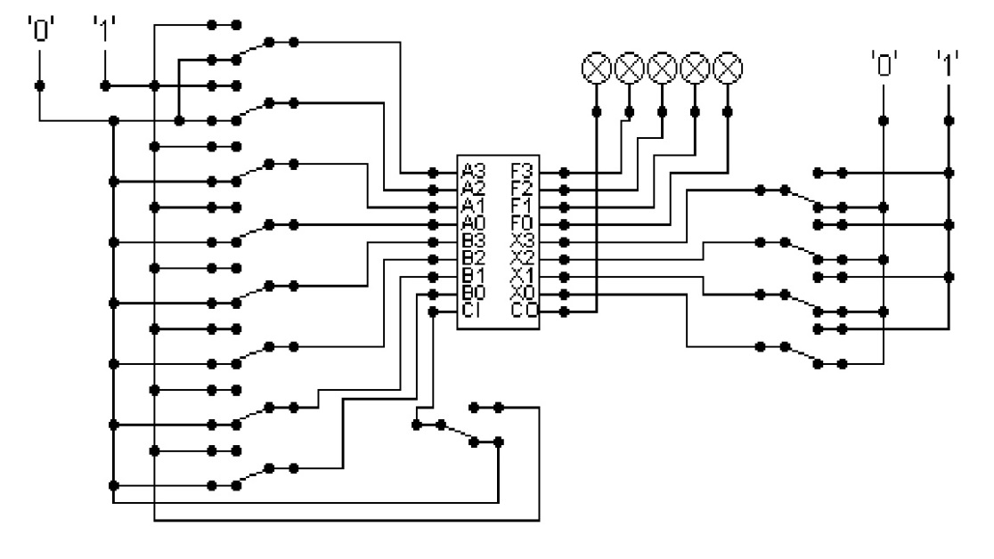
The circuit behaves like a simple arithmetic logic unit. The inputs A0-A3 represent a 4 bit binary number. Inputs B0-B3 represent another binary number. A0 and B0 are the least significant bits respectively. The following table details the functions supported by the chip. All other control lines = 0.
Function | AND | OR | XOR | NAND | NOR | NOT A | ADD | SUBTRACT
X3 – X0 | 0000 | 0001 | 0010 | 0011 | 0100 | 0101 | 1010 | 1011

Use A= 11 B=4, complete the following table in binary (15 marks):
FUNCTION | OUTPUT
AND | 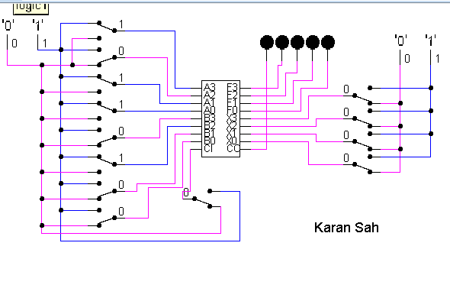
OR | 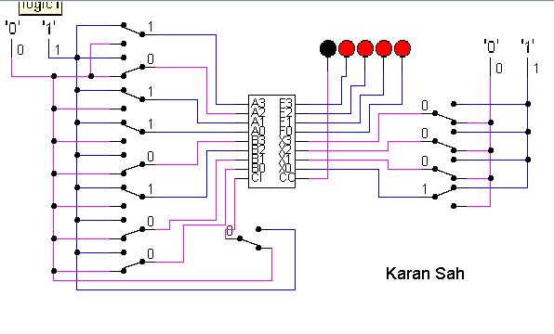
XOR | 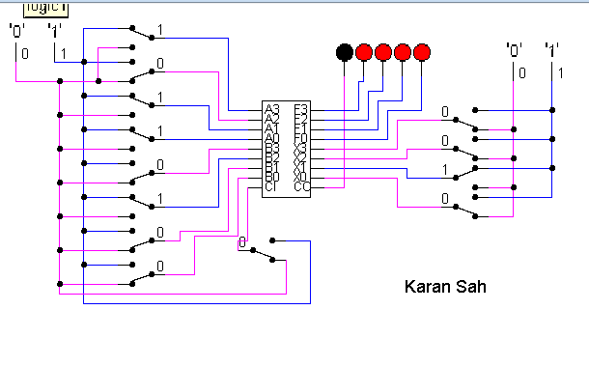
NAND | 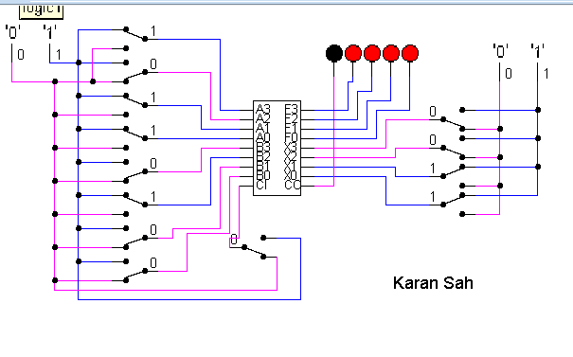
NOR | 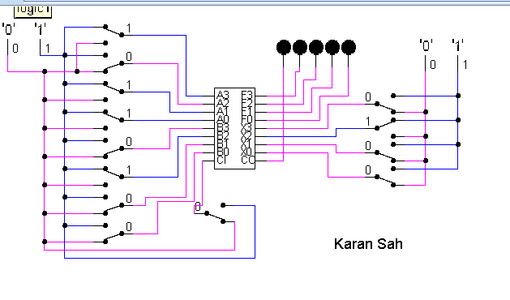
NOT A | 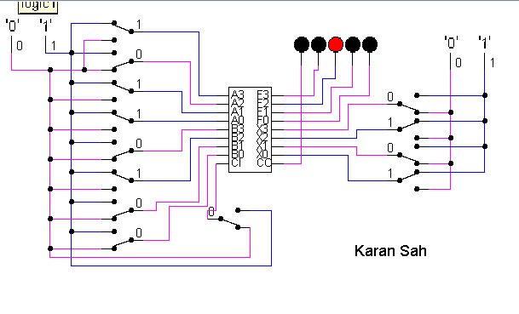
ADD | 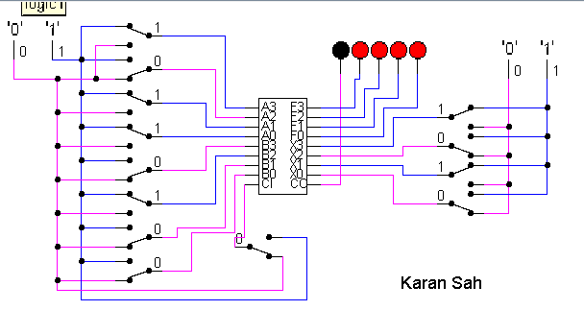
SUBTRACT | 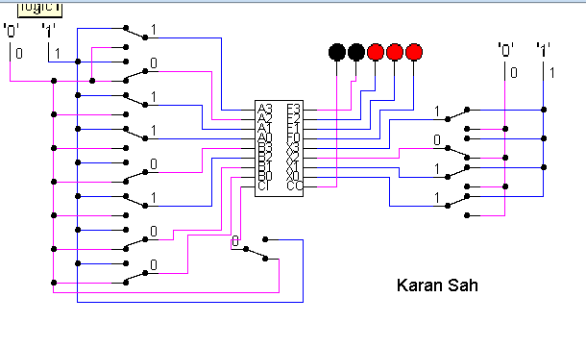

The logical operations are bitwise. Manually prove each operation has returned the correct result by (15 marks):
Example: 1 0 1 1
1 0 1 0 AND OPERATION
1 0 1 0 RESULT
Manually proven:
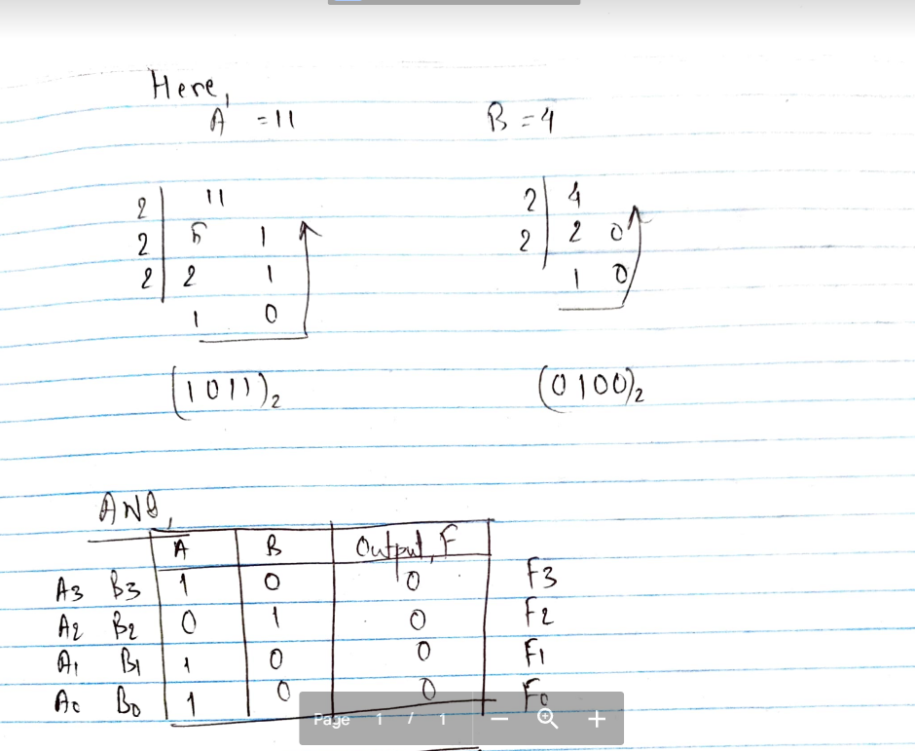
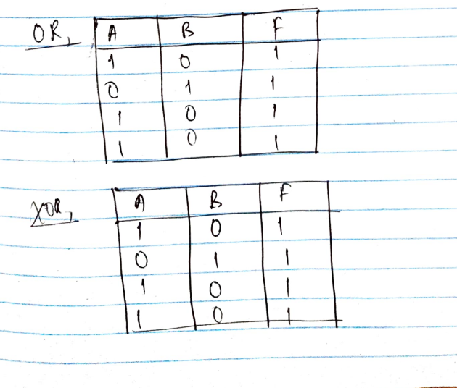
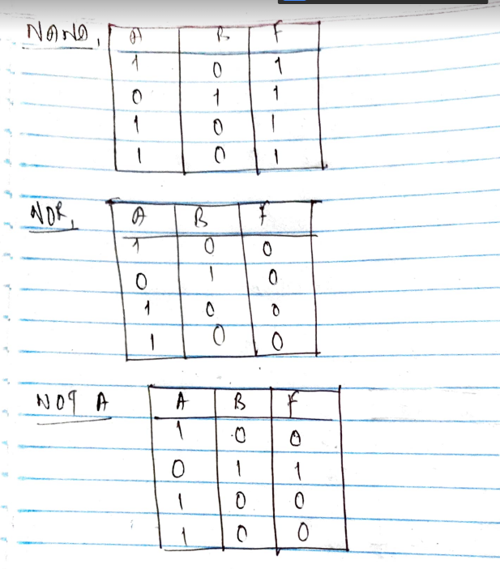
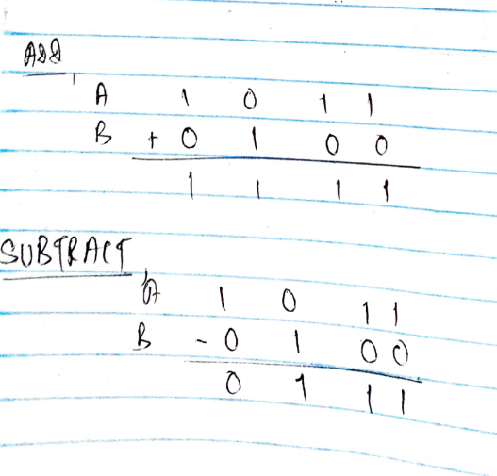
Serial to Parallel Decoder (30 marks):
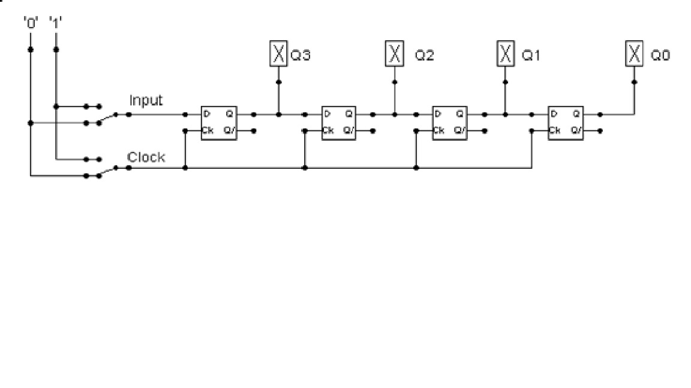
Build the circuit above and complete the following timing diagram by filling in the table spaces with ‘1’ or ‘0’. (15 marks)
Starting Figure (Oldest):
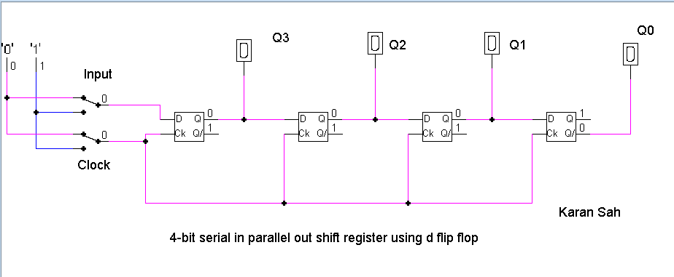
Ending Figure (Newest):
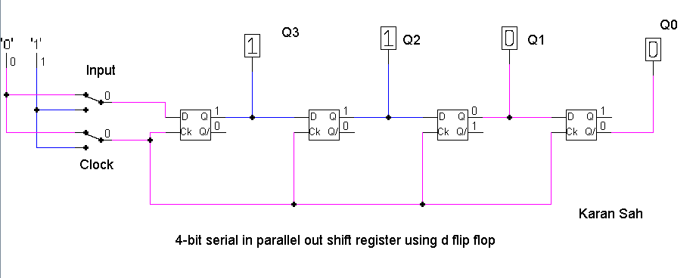
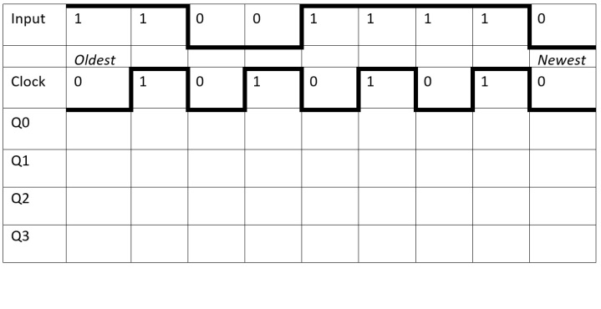

Input | 1 | 1 | 0 | 0 | 1 | 1 | 1 | 1 | 0
Clock | 0 | 1 | 0 | 1 | 0 | 1 | 0 | 1 | 0
Q0 | 0 | 1 | 1 | 1 | 1 | 1 | 1 | 0 | 0
Q1 | 0 | 0 | 0 | 0 | 0 | 1 | 1 | 0 | 0
Q2 | 0 | 0 | 0 | 1 | 1 | 0 | 0 | 1 | 1
Q3 | 0 | 1 | 1 | 0 | 0 | 1 | 1 | 1 | 1

Describe what the circuit does. (15 marks)
The above mentioned diagram is of Serial Input Parallel Output Register (SIPO). This register needs 4 clock pulses to store a data as it has to travel from Q3 to Q0.
At first, the initial value of all the outputs are 0,
At first cycle of clock (i.e. 0 and 1 of a clock), when the input is 1, the Q3 becomes 1
At second cycle of clock, the 1 from Q3 shifts to Q2, and another input 1 comes to Q3
At third cycle of clock, the 1 from Q2 shifts to Q1, the 1 from Q3 shifts to Q2 and the input of 0 comes to Q3
At the fourth cycle of clock, 1 from Q1 comes to Q0, the 1 from Q2 shifts to Q1, the 0 from Q3 shifts to Q2 and input of 0 comes to Q3

Parallel to Serial converter
Open the LogSim circuit week5.cct from the Logsim folder. It should look like this:
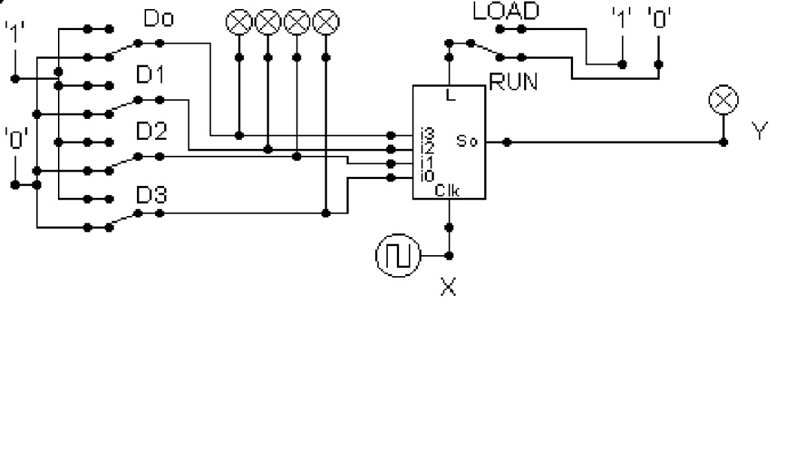
Describe what this circuit does. (15 marks)
It is a shift register whereby the input is taken in parallel and the output is given serially through load mode. The loading of data from D0 to D3 occurs at the same time that is simultaneously. After loading the output is given serially through shift mode that is when input is 1.
Enter and load data D3, D2, D1, D0 in flip flop i0, i1, i2, i3 at the same time respectively. The load occurs when input is 0. This makes input of D2 to be input of flip flop i1, input D1 is of flip flop i2 and input D0 is of flip flop i3. Now the data are stored in flop flops.
Now comes the part of shifting data from one flip flop to another which can be done through taking input 1. Q0 will shift to i2, Q1 will shift to i1, Q2 will shift to i0, giving Q3 as output

Design and add to the above circuit an additional circuit that takes the Clock X and the Output Y and decodes Y into 4 output indicators so that they match D0 – D3. Insert the LogSim GIF output of your design in the space below.
The highest marks will go to those who design the circuit such that it AUTOMATICALLY stops (not pauses) when the input to the circuit matches the output to the circuit
Note: Save your GIF image when your output indicators match the input D0 - D3. (35 marks)
Answer:
When the input is 0101, the output is same and the circuit stops although the clock cycle continues.
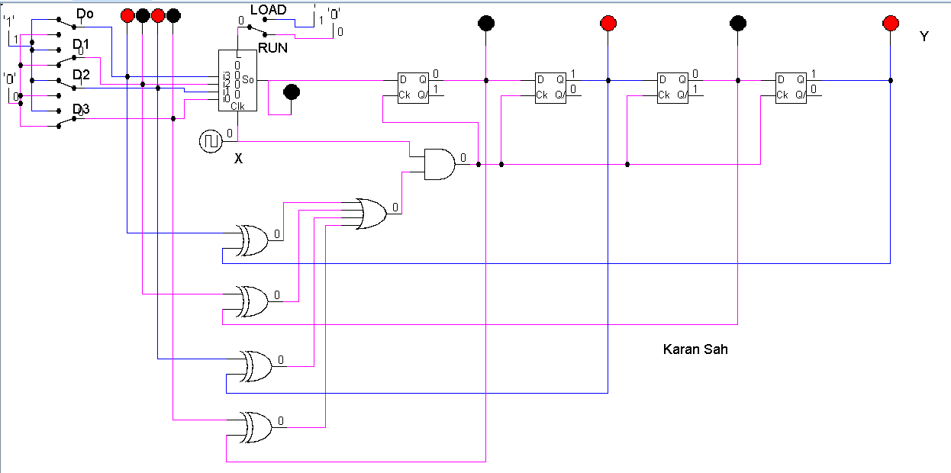
Now another case, when the input is 1111,
